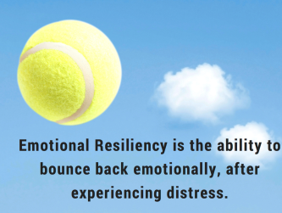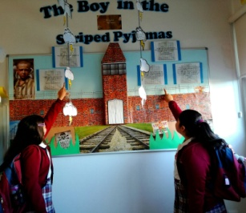
LYRICS ‘N’ LITERATURE:
BUILDING EMOTIONAL RESILIENCE
“In a world full of stresses, anxieties and pressures, I believe it is fundamental to teach our young adults how to reflect, cope and manage challenging situations that life throws at us. Social relationships, the demands of achieving high academic results, mindfulness and personal success – come and listen, feel and experience my passion for building emotional resilience into the lives of pupils and teachers”
Wednesday 15th March 2017
11:30 a.m. (intermediate to advanced)
17:00 p.m. (basic to intermediate)
And
19:45 p.m. (upper intermediate to C1)
ROOM S1

By Scott Darnell
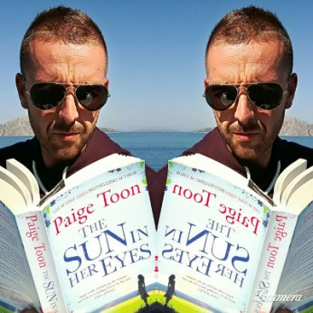
Motivational presentation by Scott Darnell, Secondary Coordinator at British College La Cañada (Valencia), friend and former EOI language assisstant.

